

One Trust Cookie Compliance Implementation

Live domain (excluding www): | website_url.ca

The script tags are the snippets of code you can use to implement the banner and preference center on your site. Once the tag is implemented on your site, any changes to your template, rules, or categorizations will be published on your site from One Trust and the script does not have to be re-implemented.
The script must be placed before any other script (Figure 1) in your site in order to ensure the banner is loaded before any other scripts have the chance to load or set cookies. This allows for the script tag to communicate the site visitor's consent preferences to downstream vendors and for those vendors to show content and set cookies as allowed by the site visitor.
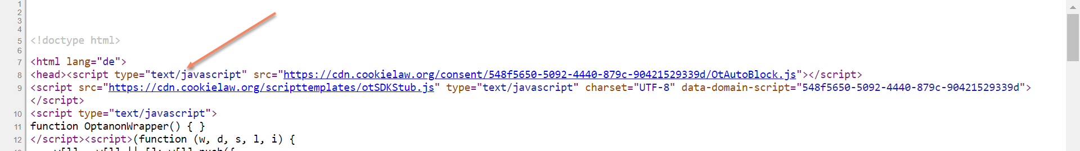
Figure 1: First tag in <head> section
Required Components
- Production script

Optional Components
- Cookie Settings link
- Testing script

Additional info
- Platform Integrations
- Language translations

1. Production site Script (required on live domain)
<!-- OneTrust Cookies Consent Notice start for website_url.ca -->
<script type="text/javascript" src="https://cdn.cookielaw.org/consent/script_id_here/OtAutoBlock.js" ></script>
<script src="https://cdn.cookielaw.org/scripttemplates/otSDKStub.js" data-document-language="true" type="text/javascript" charset="UTF-8" data-domain-script="script_id_here" ></script>
<script type="text/javascript">
function OptanonWrapper() { }
</script>
<!-- OneTrust Cookies Consent Notice end for website_url.ca -->

ID for plugins that don’t require the full code (Drupal, Wordpress etc. Generally the CookiePro plugin by One Trust is used in many common CMS systems)
script_id_here

2. Cookie settings link
This component in hyperlink format is now optional as there will be a shield or cookie icon pushed out as standard from the One Trust environment template once the main script has been embedded in a site(See Figures 2 & 3 depending on the script version published). The settings button is required as it allows the user to access the privacy center when the banner has been closed, so they may change their cookie preferences at any time. The option to change preferences needs to be universally accessible throughout a user’s journey. If the cookie settings is to be used as an additional link in the header or footer, the CSS class must not be changed. The ID may be used for additional styling of the link as necessary.
While the element shown for the settings button is a HTML link, the element can be multiple types such as <div>, <button> etc. What enables the respective element to function as a settings button, is the use of the class “ot-sdk-show-settings”. Implementation will be different depending the on platform so business and development should work together to discover what element type and placement works best on their site.
The “Cookie Settings” text also does not need to changed regardless of language. The One Trust script will override whatever text has been placed within the settings element tags and is controlled from within the One Trust platform.
<!-- OneTrust Cookies Settings button start -->
<a href="#" id="custom-ot-sdk-btn" class="ot-sdk-show-settings"> Cookie Settings</a>
<!-- OneTrust Cookies Settings button end -->

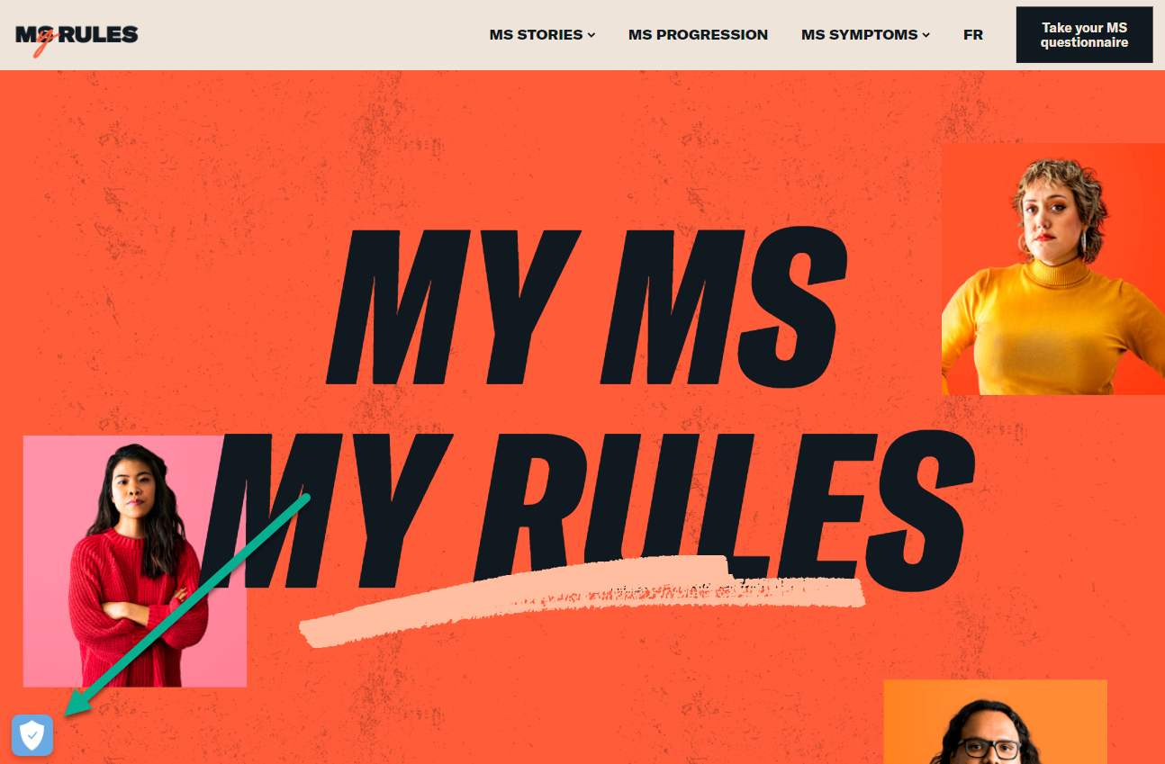
Figure 2: New shield icon pushed out from One Trust environment template(version 6.28 & below)

Figure 3: New shield icon pushed out from One Trust environment template(version 6.29 & upwards)

3. Testing Script (staging/dev domain, optional if testing)
<!-- OneTrust Cookies Consent Notice start for website_url.ca -->
<script src="https://cdn.cookielaw.org/scripttemplates/otSDKStub.js" data-document-language="true" type="text/javascript" charset="UTF-8" data-domain-script="script_id_here-test" ></script>
<script type="text/javascript">
function OptanonWrapper() { }
</script>
<!-- OneTrust Cookies Consent Notice end for oncocorner.ca -->

Test-ID for plugins that may not require the full code (Drupal, Wordpress etc. Generally the CookiePro plugin by One Trust is used in many common CMS systems)
script_id_here-test

4. Platform Integrations
If a website is based on a static code package, the full script will need to be added as instructed above. The ID part has been included for cases where an external platform is using a plugin that does not require the full script such as Drupal or WordPress that both use the CookiePro by One Trust plugin. Please note that while this particular plugin states you need a CookiePro account in some cases, this is not necessary since we have been provided the script from our client’s One Trust account. Depending on the process and governance of other platforms, there may also be custom development whereby an ID field is added to a CMS in order to add the ID which injects the full script into the site. The onus of this is on the business and their development partner.

5. Language translations
One Trust translations for the banner and privacy center are enabled for all countries within the platform. In order for the system to display the correct language, the lang=”xx” parameter must be present in the site HTML tag as seen in Figure 4. The part of the One Trust script which has enabled this language detection functionality is: data-document-language="true"

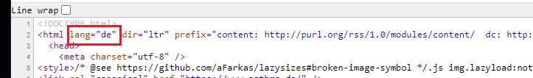
Figure 4: For this particular site, German will be displayed by One Trust

